## **Lab 07 - Histogram Equalization**

**Name: Ahmad Amjad Mughal**

**Reg No: 121672**

**Class: BSCS-6C**

1. **Write a program that shows the histogram for a given image. For displaying the histogram,**

**Code**

import matplotlib.pyplot as plt

import PIL

from PIL import Image

import numpy as np

import math

image_used = Image.open("hist2.tif").convert('L')

image_array = np.asarray(image_used)

plt.hist(image_array.flatten(),128, color = 'blue')

plt.title("Histogram of given image")

plt.xlabel("Grey Level")

plt.ylabel("Number of Pixels")

plt.show()



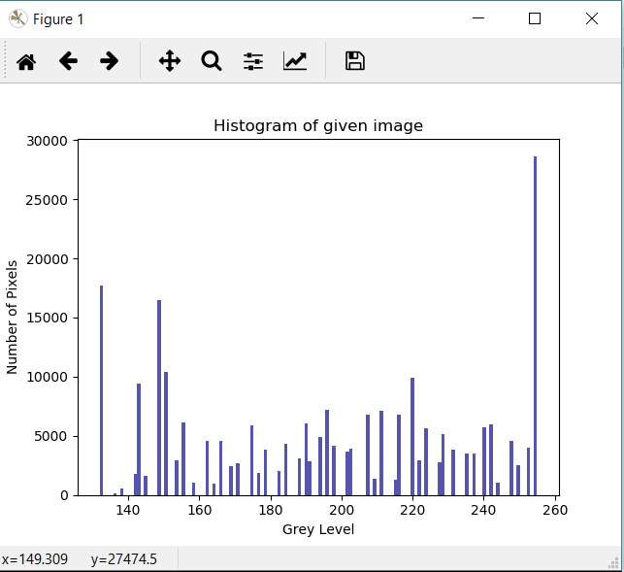

1. **Write a program that equalizes the histogram of a given image. Consider the formula,**

**Code**

import matplotlib.pyplot as plt

import PIL

from PIL import Image

import numpy as np

import math

image_used = Image.open("hist2.tif").convert('L')

image_array = np.asarray(image_used)

plt.hist(image_array.flatten(),128, color = 'blue')

plt.title("Histogram of given image")

plt.xlabel("Grey Level")

plt.ylabel("Number of Pixels")

plt.show()

value = 256

x, y = image_used.size

image_size = x*y

count = np.zeros(value)

pdf = np.zeros(value)

cdf = np.zeros(value)

t = np.zeros(value)

for k in range(value):

for i in range(x):

for j in range(y): #Iterating columns

if image_used.getpixel((i,j)) == k:

count[k] = count[k] + 1 #incrementing

pdf[k] = count[k]/image_size #finding pdf

if k == 0:

cdf[k] = pdf[k]

else:

cdf[k] = cdf[k-1] + pdf[k]

t[k] = math.floor((value-1)*cdf[k])

img_equal = Image.new('L',(x, y)) #storing equalized image

eq_map = img_equal.load()

for i in range(x):

for j in range(y):

eq_map[i, j] = t[image_used.getpixel((i,j))] #equalized image

img_equal.show() #Showing image

img_equal.save('imageeeeeeeee.tif')

img_histo = ap.asarray(img_equal)

plt.hist(img_histo.flatten(),128, color = 'blue')

plt.title("Histogram of given image")

plt.xlabel("Grey Level")

plt.ylabel("Number of Pixels")

plt.show()

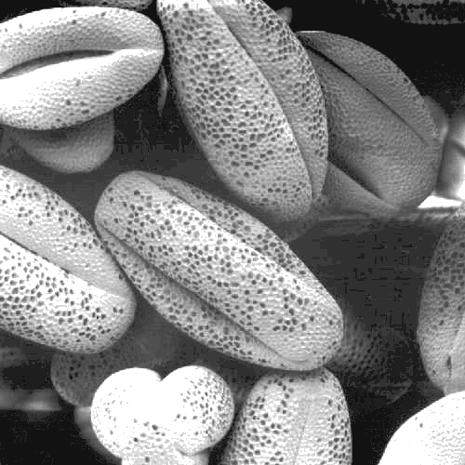

1. **Show the histograms before and after equalization. Again consult Matplotlib. Opencv can also be an option.**

**Original Contrasted**

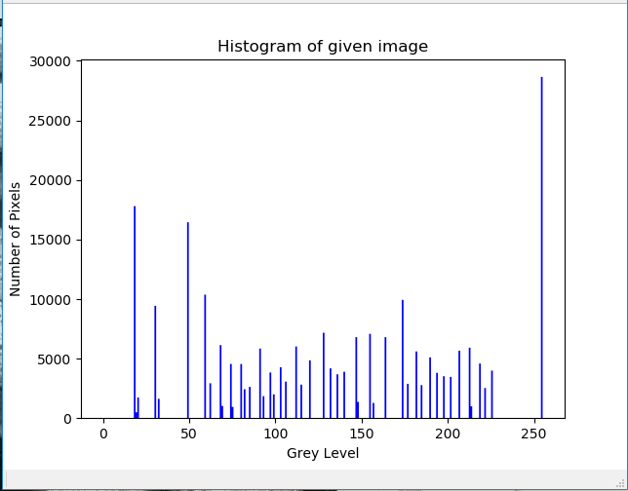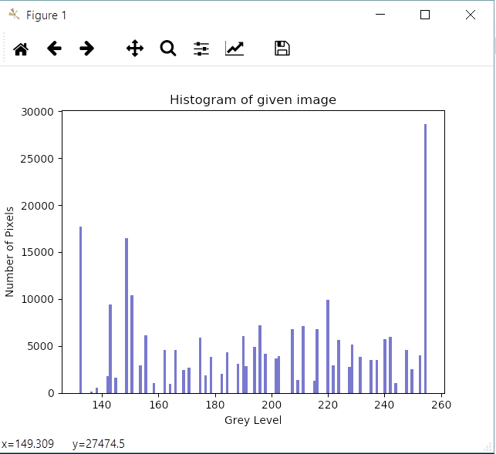

1. **Does the equalized histogram have a uniform distribution?**

Ans: Not Completely but nearly has a uniform distribution. There is a reason as mention below:

* Histogram of histogram-equalization is flattened as there creates jumps that terms it in a category of non-uniform histogram.
* As after performing histogram equalization on image, there’s some chance of noise enhancement.